Blackjack

- Algorithms:
- Start the game by outputting asking for the player name to use in the game.
- Take users name as input to player_name.
- Make a string called rules
- Make a string called would_you like_rules
- Open a file named rules.txt and take the data and put it into the string rules (which will be the rules)
- Close file
- Output would you like to see the rules
- set input to would_you_like_rules
  - if yes
    - output string rules
- Make a int value of a random number 2000-10000 name it money
- Output the amount of money the player will start with
- Make a int variable named bet
- Make a string variable name double_down_question=”y”
- Make a string variable name hit and set it to “h” (hit= ”h”)
- Make a vector for the dealer and the player to hold cards
- Make a string variable for keep_playing=”y”
- Make a while loop that says while keep_playing is “y”
  - Output asking the player how much they would like to bet.
  - Input the amount to player puts in into bet
  - Make an int for the sum of the sum of the dealer’s hand and the players hand
  - Make a while loop with a counter for the first two cards for the dealer and the player.
    - Make a random number generator to get a random number to be a card
  - After the while loop output the players two cards and then show the first card of the dealers.
  - Output would you like to double down
  - Make a while loop that says while hit=”h”
    - if the bet amount is not 2*bet > money && double question is yes then
    - output would you like to double down
      - if yes
        - make the bet times 2
        - give player one more card
        - make hit=”s”
        - make double_down_question=”n”
      - if no
        - change the make double_down_question=”n”
    - output to the player if they would like to hit or stay
    - if hit
      - make a random number to make a random card to go into player’s hand
      - get the sum of the card that the player has
      - if sum of player hand is >=22
        - FOR YES
          - Make hit=”s”
      - If stay
        - Get the sum of players cards
        - While dealer hand<=16
          - Get another card for the dealer with a random number generator
      - If players cards are > dealer’s cards and players cards aren’t over 21
        - Output player has won
      - Else if players cards are <dealers and dealer’s cards aren’t over 21
        - Output dealer has won
      - Else
        - Output it’s a tie
      - Out players full cards and dealer’s full cards, the amount of money the player has now.
      - Output would you like to keep playing
      - Input players answer to keep_playing
  - If no they broke the loop
  - Output a good bye message base on if they have money or not
    - If no money
      - a mean message
    - If yes money
      - a nice message welcoming them back.
      - Make an int highscore
      - Open a file called highscore.txt
      - Take the highscore from the file and send it to the int highscore
      - If highscore < then money
        - Over wright the file add in name and then the amount of money player has
      - If highscore> then money
        - Show the old players name and there highscore.
      - Close the file highscore.txt
Use Case diagram: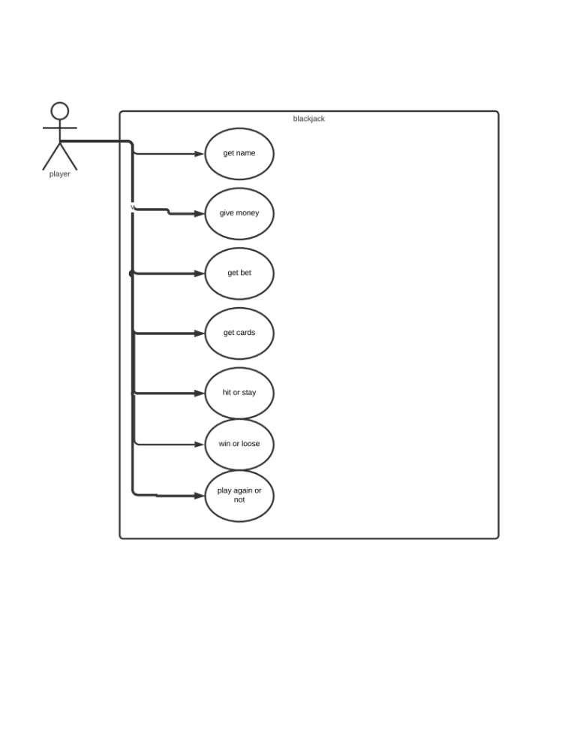
Activity diagram: https://app.diagrams.net/ 